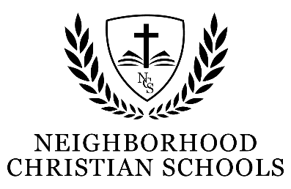
Statement of Faith

We believe that God reveals Himself through the creation, preservation, and government of the universe.

We believe that God makes Himself more clearly and fully known through the Scriptures, which are the only inerrant and infallible Word of God, our ultimate and final authoritative rule for faith and practice. These Scriptures are made up of 66 books, from Genesis to Revelation, the authority of which depend not upon the testimony of any man or church, and are all to be received as the Word of God.
We believe that there is but one living and true God, eternally existent in three Persons of one power, substance, and eternity—Father, Son and Holy Spirit. He is perfectly wise, the overflowing fountain of all good. He is omnipotent, omnipresent, and omniscient. In all things He is limited by nothing other than His own nature and character. We believe the God we serve is holy, righteous, good, loving, and full of mercy. He is the Creator, Sustainer, and Governor of all that has been made.
We believe in the true deity and full humanity of our Lord Jesus Christ, such that two distinct natures, divine and human, were inseparably joined together in one person, without conversion, composition, or confusion. We believe in His virgin birth, in His sinless life, in His miracles, in His vicarious and atoning death through His shed blood, in His bodily resurrection, in His ascension to the right hand of the Father and in His personal return in power and glory.
We believe that Adam was made from the dust of the ground and formed after God’s image and likeness, which was good, righteous, and holy. Because of Adam’s sin all mankind is in a state of rebellion against God. For the salvation of such lost and sinful men, regeneration by the Holy Spirit is absolutely necessary.
We believe that salvation is by grace through faith alone, and that faith without works is dead. We believe that God freely justifies His own, not by infusing righteousness into them, but by pardoning their sins, and by accounting and accepting their persons as righteous, for the sake of Jesus Christ alone.
We believe in the present ministry of the Holy Spirit, by whose indwelling the Christian is enabled to live a godly life, as the Spirit of Christ within us enables us to do freely and cheerfully what the will of God revealed in Scripture requires to be done. We believe that good works are only those which arise from true faith, conform to God’s Word, and are done for His glory.
We believe God has appointed a day when He will judge the world in righteousness through Jesus Christ. We believe in the resurrection of both the saved and the lost; those who are saved to the resurrection of life, and those who are lost to the resurrection of damnation.
We believe in the spiritual unity of all believers in our Lord Jesus Christ. All who are united to Christ as Head of the Church are united to one another in love, and have communion in each other’s gifts and graces.
We believe that God designed marriage as the life-long covenant between one man and one woman, and that all forms of sexual activity outside of God’s design for marriage are sin.
We believe that God immutably creates each person to reflect His image as male or female.
We also affirm the Chicago Statement on Biblical Inerrancy (1978); Chicago Statement on Biblical Hermeneutics (1982); and the Chicago Statement on Biblical Application (1986).

