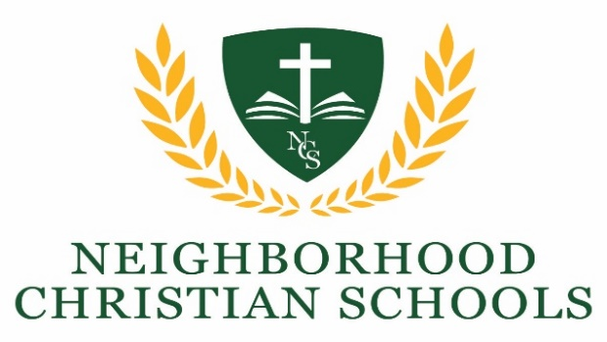

Steps to Re-Enrollment for the 2026-2027 School Year

Students Applying for Re-Enrollment:

- Complete the Request for Re-Enrollment Form and return to NCS along with the applicable re-enrollment fees per student (see the schedule below).

- Each student must reaffirm their agreement with the Student Handbook, and the Statement of Faith. The current handbook is available to read online at www.classicalncs.com and will be updated as needed by the administration. If in agreement with the Handbook and Statement of Faith, sign the Student Handbook Agreement form (one per student) included in the re-enrollment packet and return with the Request for Re-Enrollment.

- Regular church attendance at a like-minded church (please refer to the Statement of Faith) is required for re-admission to NCS. A Pastor Reference form is included in the re-enrollment packet and must be given to the family’s pastor and returned to NCS for the re-enrollment request to be processed.

- A copy of your 2025 Tax Return is required to calculate tuition for the 2026-2027 school year. You may submit a copy of your tax return at any time before June 15, 2026.

- You will be notified of acceptance or denial for each applicant. Accepted applicants will receive all appropriate information and forms for preparing for school, including financial arrangements.

Additional Students:
If you want to add a new student, (i.e., a Kindergarten student) please complete and return the Additional Student Enrollment for Current NCS Family form included in this packet.

Re-Enrollment and New Student Application Fee:
Apply by:
February 1 - April 30 | $25.00 per student
May 1 – June 30 | $50.00 per student
July 1 – July 15 | $75.00 per student

